PEDAGOGICAL TECHNOLOGIES THAT CAN BE USED IN ENGLISH LESSONS
Sultonova Fotima Khanafiyayevna
Shaykhantohur district of Tashkent city Intellectual School «Wisdom Star» English teacher
ANNOUNCEMENT: This article describes the steam approach, interactive methods that can be used in English lessons, and their importance in English.
KEYWORDS: Pedagogical technology, pen on the table, untraditional and aquarium method.
The essence of "pedagogical technology" is the didactic purpose, which is reflected in the pre-design of the educational process, taking into account the achievement of the required level of mastery and its implementation. In contrast to the methodological development of the lesson, which is aimed at the active work of the teacher, the pedagogical technology of education is focused on the learners, taking into account their individual and joint activities with the teacher. Focuses on learning materials. The central problem of pedagogical technology is to ensure the achievement of educational goals through the development of the student's personality.
METHOD ON THE TABLE
This method is convenient for practical training. A small group of students, who have written their answer to the question, place the pen on the table and pass the sheet to the partner next to them. A student who cannot write a question will not put the pen on the table. The answers to the same question from students in several small groups are collected and discussed together.
The advantages of this method are: the teacher sees who is ready and who is not ready for the lesson; a student who is not prepared for the lesson will gain a lot of useful knowledge on the topic under discussion during the oral discussion; this method is a small group work that strengthens and consolidates student discipline because a student who thinks long and hard about his or her answer option spends time allotted to the whole group. Also, if the student is not ready for the lesson, then it is a reason for the group will give; students answer their questions twice, both in writing and orally analyze during the discussion.
AQUARIUM METHOD
Three students from the group are asked to sit around a table in the middle of the room and discuss the problem together for about ten minutes are asked to comment. These three students are like the fish in an aquarium. Observers sitting around listen carefully to the opinions of the students in the middle, write down the answers correctly and incorrectly, and express their views during the discussion. Students in the middle who are not able to comment sufficiently give their seats to observer students who have a strong opinion. Opinions on each problem are summarized by the teacher with the participation of students.
SKARABEY TECHNOLOGY
Scarab is an interactive technology that allows students to develop intellectual connection, logic, memory, solve a problem. Develops the ability to express one's thoughts openly and freely. This technology allows students to independently assess the quality and level of knowledge objective assessment, identification of concepts and perceptions about the topic under study allows It is about expressing different ideas at the same time and between them allows you to determine the dependencies.
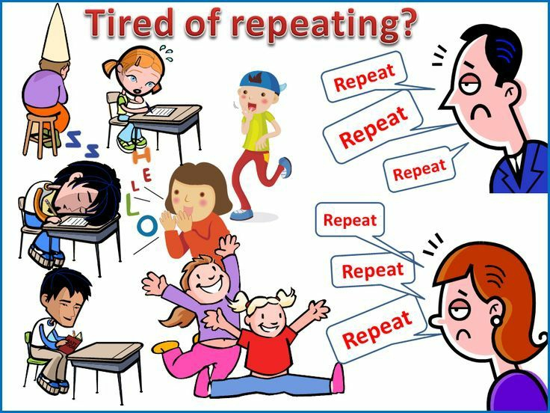
DELFI TECHNOLOGY
The content of this technology is an alternative to the problem posed by the community categorize the solutions according to the levels of acceptability of each of them. From evaluating the importance or insignificance, choosing the best option on this basis consists of For example, the area of ​​the ground in the plug is 15, 20, 25, 30, 35, 40, 45 cm let it be turned upside down. Specific land area
to determine which of these options is best for reversal each of which is based on the available agrotechnical factors for plowing the land assessed by students under the guidance of a teacher. Each small group can suggest their own options, and then the ideas can be summarized and the best option can be selected.
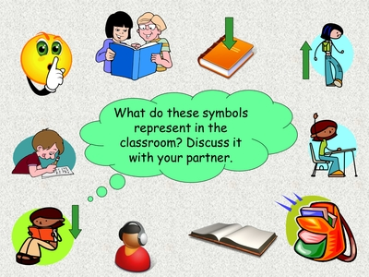
References:
- Avliyakulov N.X., Musaeva N.N. Modular learning technologies. - T .: Science and Technology Publishing House, 2007
- Ishmuhamedov R., Abdukodirov A., Pardaev A. Innovation in education technology / Practical recommendations. - T .: Talent Fund, 2008.

